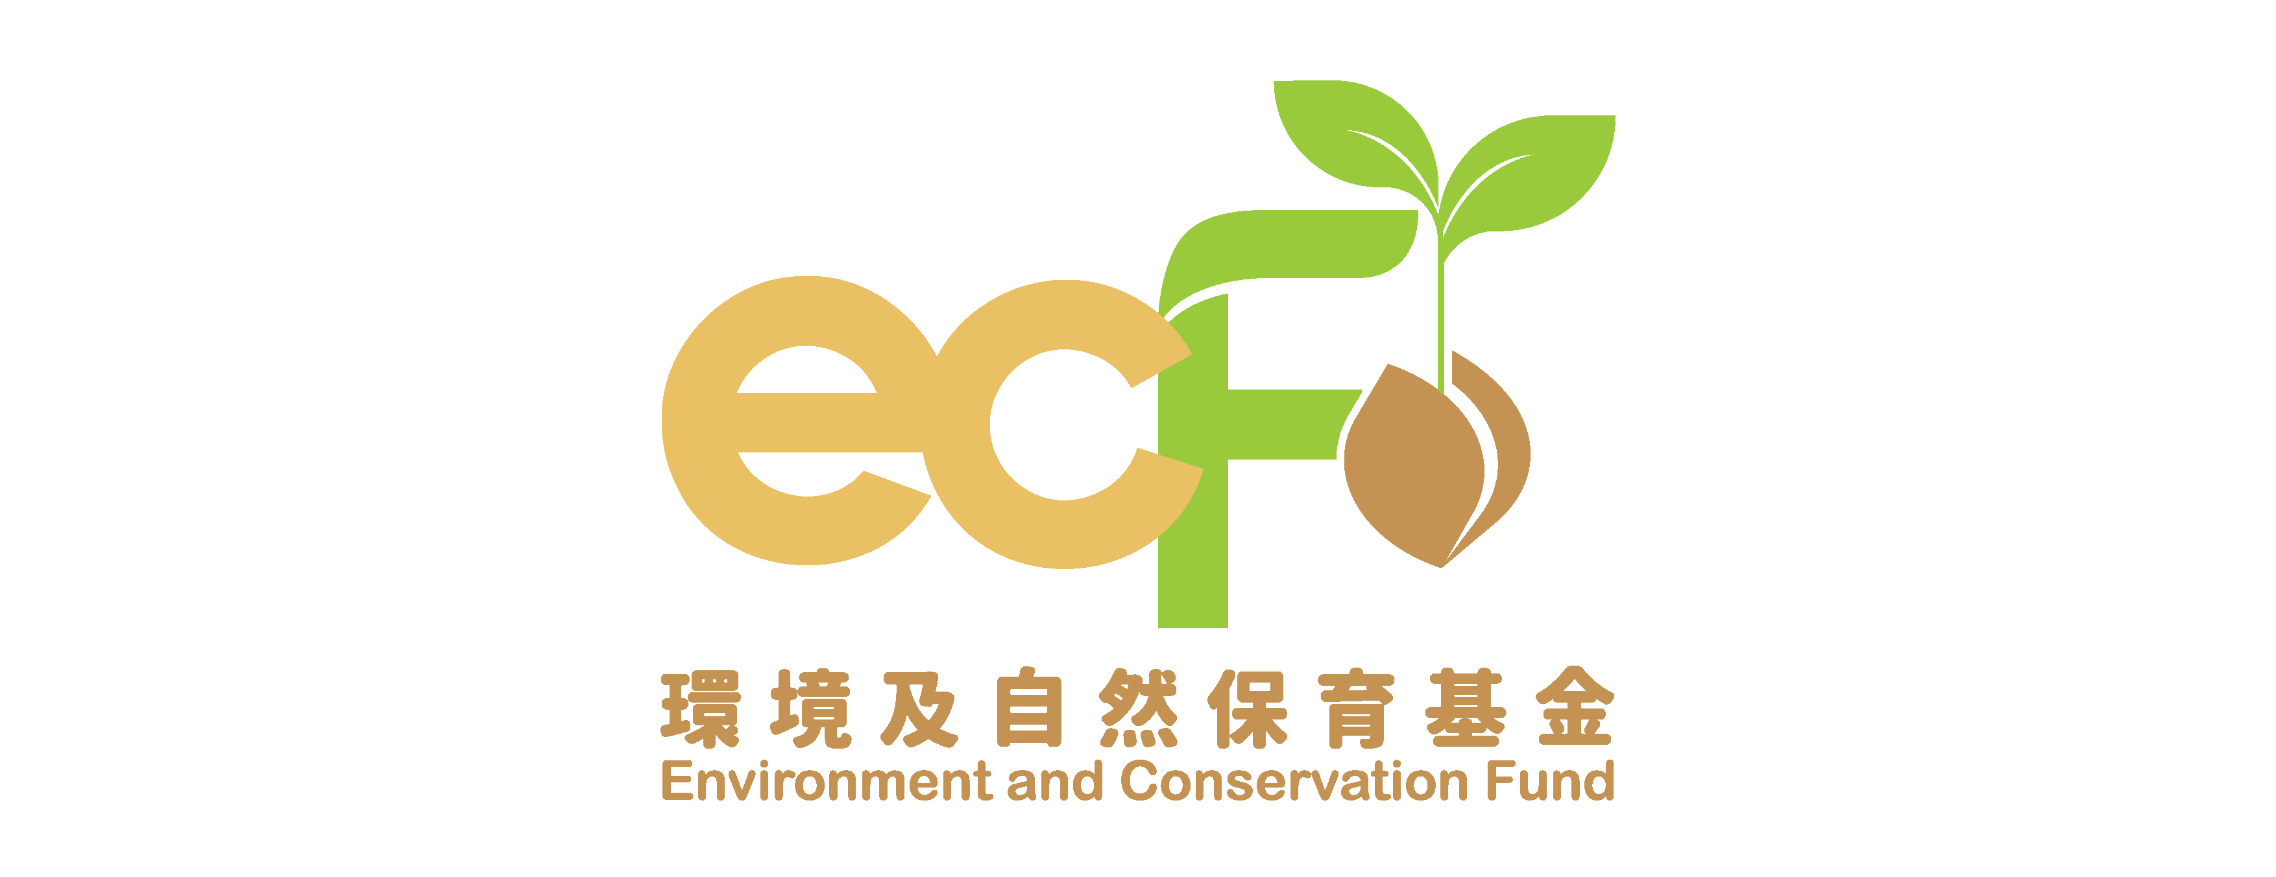
Progress Report

Funding Scheme: | Environmental Research, Technology Demonstration and Conference Projects
Project Number: | ECF
Project Title: | Environment and Conservation Fund
Name of Organisation:
Reporting Period: | From: |  |  | To:
Date of Report Submission:
I certify that this report and statement of account are correct and that the goods and services purchased and acquired are necessary for the activities of the project and that the prices are fair and reasonable.

Note:
This report shall be completed and signed by the Principal Investigator of the project as stated in the application form submitted.
Information of the Principal Investigator
Name:
Position Held:
Signature:
Official Chop of Organisation:

Please complete this Progress Report and submit it to the Research Projects Vetting Subcommittee (RPVSC) Secretariat once every 6 months (beginning from the project commencement date). This progress report may be made available for public inspection. Please note that this report is for reporting the progress of the project only. As stated in the Approval Letter, a written application must be submitted to the Secretariat well before the completion date of the project for approval of any changes to the project.
(I) Progress of the Project

1. Project schedule

Commencement Date |  | Completion Date
Original | Actual | Original | Expected / Actual

2. Summary of activities organised / implementation progress to date

3. Please set out in detail how far the planned deliverables have been achieved, and account for any failure or anticipated failure to achieve the planned deliverables in full.

4. Publicity materials or publications produced (if any) (Please attach a copy for each type of material)

5. Project slippage, as compared with original schedule. (Request(s) for extension of project duration and/or other project variations including the approved budget must separately be put up to the RPVSC Secretariat with full details and justifications for processing.)

6. Problems encountered during the reporting period (if any)

7. Remedial measures taken (if any) and their effectiveness

8. Forecast of the remaining project period – describe the major activities to be carried out in the remaining project period

(II) Financial Report

- Detailed breakdown of expenditure (For Universities and THEi, please provide a Statement of Account with clear breakdown of the income and expenditure items certified by concerned Finance Office. For others, please complete Enclosure.)

- Virement of fund (provide the details and reasons on overspending items)

The Principal Investigator hereby confirms that the expenditures for “staff cost” have not, at any time, exceeded the maximum of ECF’s funding scale for the various categories of research supporting staff, as set out in the Guide to Application and indicated below –

Student Research Assistant: | maximum of HK$63 per hour
Research Assistant II: | maximum of HK$18,000 per month (full-time) or HK$105 per hour (part-time)
Research Assistant I: | maximum of HK$23,000 per month (full-time)  or HK$130 per hour (part-time)
Senior Research Assistant: | maximum of HK$34,220 per month (full-time)  or HK$200 per hour (part-time)

- Require disbursement of further payment? (please tick as appropriate)

 | Yes, because the previous payment has been mostly (i.e. ≧80%) spent |  | No
Yes, further disbursement is required for undertaking the following
(please provide below)

Enclosure

Environmental Research, Technology Demonstration and Conference Projects
Statement of Accounts (Income and Expenditure) for Progress Reporting

For recipient organisations other than Universities and THEi, please read paragraph 4.7 of the Guide to Application carefully for the auditing requirements of the projects.

a) Detailed breakdown of incomes (including ECF grants and project interest):

Items | Amount ($)

b) Detailed breakdown of expenditure:

Budget Items  (please set out ALL approved budget items) | Approved Budget  ($) | Expenditure during the Reporting Period  ($) | Accumulated Expenditure  ($)
I. Staff cost
Sub-total:
II. Equipment and consumables
Sub-total:
III. Others
Sub-total:
Total:

Signature of Organisation’s Person-in-charge: |  |  | Official Chop of Organisation:
Name and Post of the Organisation’s Person-in-charge: |  |  | Official Chop of Organisation:

