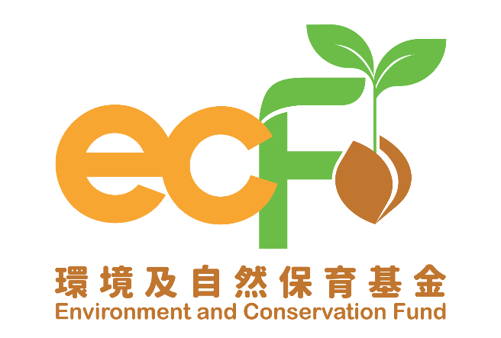
Progress Report
(Applicable to “Surplus Food Recovery Projects” Only)

Funding Scheme: |  | Practice and Action Projects – Surplus Food Recovery Projects
Project Number: |  | P&AXXXX
Project Title: |  | Environment and Conservation Fund XXXX
Recipient Organisation:
Reporting Period: |  | dd/mm/yyyy – dd/mm/yyyy
Report Submission Date: |  | dd/mm/yyyy
Declaration of Person-in-charge/Project Leader:  Note:  This report shall be signed by the person-in-charge or the project leader as stated in the application form |  | I certify that the attached progress report and statement of accounts are correct, including:  - the collaborating organisations and/or service providers/contractors and/or the project employees under the captioned project have signed the Confirmation on National Security;  - the goods and services purchased, acquired and charged to this project are for the sole use of the project and that the prices are fair and reasonable;  - the expenditure charged to the project has been settled and that it has not been/will not be claimed under other project(s) funded by the Environment and Conservation Fund or subsidised by other source(s) of funding; and  - *the balance of grant to be claimed/the amount of unspent grant to be returned to the Environment and Conservation Fund is correct.  *Delete whichever is inappropriate.
Information of the Person-in-charge/Project Leader
Name:
Position Held:
Signature: |  |  | Official Chop of Organisation:

Please complete this Progress Report and submit it by post to the Secretariat every six months (beginning from the project commencement date) or within the timeframe as specified in the Approval Letter (whichever is the earlier). This progress report may be made available for public inspection. Please note that progress reports are for reporting the progress of the project only. A written application must be submitted to the Secretariat for approval of any changes to the project in accordance with the Approval Letter.
- Practice and action activities(Please provide relevant record and/or photos (e.g. photos of recyclables distribution activities)) ¹

  - Progress summary of quantitative target(s) in recycling activities

Date | Targets in Work Plan |  |  |  |  | Progress during Reporting Period* |  |  |  |  | Achieve-ment Status (Please select “✓” if achieved)
Date | Recovery Amount (tonnes) |  | Distribution Amount (tonnes) |  | Number of Benefici-aries (man-time) | Recovery Amount (tonnes) |  | Distribution Amount (tonnes) |  | Number of Benefici-aries (man-time) | Achieve-ment Status (Please select “✓” if achieved)
Date | Fresh Food | Packed or Canned Food | Direct Food Redistri-buted | Cooked Food | Number of Benefici-aries (man-time) | Fresh Food | Packed or Canned Food | Direct Food Redistri-buted | Cooked Food | Number of Benefici-aries (man-time) | Achieve-ment Status (Please select “✓” if achieved)
Jan 2026 | 0 | 0 | 0 | 0 | 0 | 0 | 0 | 0 | 0 | 0
Feb 2026 | 5 | 3 | 3 | 3 | 20 | 8 | 5 | 5 | 4 | 40
Mar 2026
Apr 2026
May 2026
Jun 2026
Total

  - Actual outlet(s) of recyclables (Please list out the actual outlets of re-distribution or re-use, treatment or intake by downstream recyclers)

  - Progress summary of quantitative target(s) of other activities¹

Targets in Work Plan |  |  | Progress during Reporting Period
Indicator(s) | Quantitative Target(s) | Unit | Quantitative Outcome(s) / Implementation Progress | Unit | Achieve-ment Status (Please select “✓” if achieved)

- Promotional activities (Inclusive of promotion of project and promotion of project achievements)

2.1 Progress summary of activities/promotional platform(s) (Please provide two photos for each activity; please provide the screenshots of the promotional platform(s))¹

Targets in Work Plan |  |  | Progress during Reporting Period
Promotional Means | Content | Planned Reach/ No. of Participants/ Expected Benefits | Date | Period | Venue | Actual Reach/No. of Participants/ Benefits | Achievement Status (Please select “✓” if achieved)
Seminar | Proper recycling guide | 150 participants | dd/05/2026 | 1.5 hour | XX Community Centre | 180 participants
Social media promotion | Create social media page and account | 1,000 followers | dd/01/2026 | N.A. | Facebook page (XXX) and Instagram account (XXX) | 1,200 followers
Social media promotion | Waste reduction tips | 100 likes, 250 reach | dd/02/2026 | N.A. | Facebook page (XXX) and Instagram account (XXX) | 100 likes, 250 reach
Social media promotion | Seminar promotion | 100 likes, 250 reach | dd/04/2026 | N.A. | Facebook page (XXX) and Instagram account (XXX) | 150 likes, 300 reach
Social media promotion | Waste reduction tips | 100 likes, 250 reach | dd/06/2026 | N.A. | Facebook page (XXX) and Instagram account (XXX) | 150 likes, 250 reach

2.2 Publicity or educational materials produced (Please attach a copy for each type of materials)

Promotional Means * | Quantity Produced | Quantity Distributed
*Examples include newsletters, posters, leaflets, press clippings, etc.

- Project variation and challenges encountered

  - Changes of project schedule, content and/or scope as compared with the approved work plan (If any, please specify the changes with reasons)

* Prior approval shall be obtained from the Practice and Action Projects Vetting Subcommittee Secretariat for any changes of the work plan.

  - In case of unsatisfactory progress as compared with the work plan, please specify the reasons and the remedial measures taken, planned and/or recommended (If any)

  - Key challenges encountered during the reporting period, remedial measures taken and their effectiveness (If any)

- Financial reporting

4.1 Overall position

Opening balance at the start of the reporting period: | HK$
Income during the reporting period*: | HK$
Less expenditure during the reporting period*: | HK$
Closing balance at the end of the reporting period: | HK$

*Please provide the breakdowns of income and actual expenditure by completing the statement of accounts provided by the Secretariat.

4.2 Is a further disbursement of fund needed? (please tick as appropriate)

 | Yes* |  | No
 |  |  | (Please forecast the date on which a further disbursement is required (dd/mm/yyyy): | )

*The financial position of the project submitted should justify that not less than 80% of the previous payment(s) has/have been/will soon be spent such that a further disbursement is required for undertaking the project as scheduled.

4.3 Mailing address of payment cheque:

¹ (i) For project that is required to report the progress with records and photos via the smart electronic means, there is no need to attach the relevant records and/or photos along with this report. (ii) Recipient organisation shall report project progress according to the targets set in work plan. (iii) Contents highlighted in grey are provided for reference only, please fill in the table according to the actual situation. (iv) Please expand the table if necessary.

