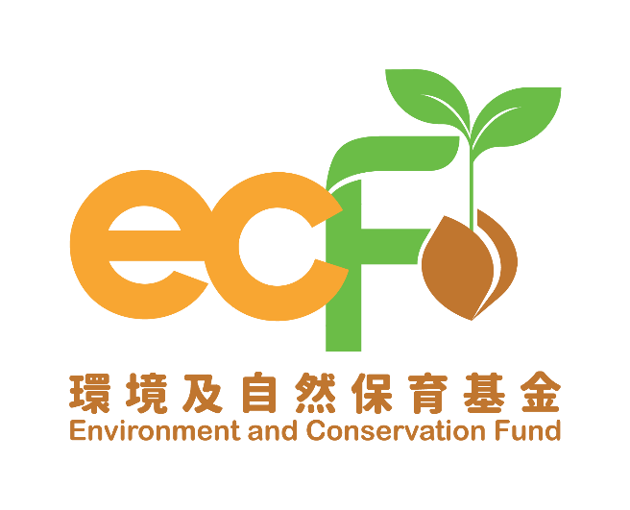
Progress Report
(Applicable to All Project Themes
Except “Clean Shorelines (Small Scale) Projects” and “Surplus Food Recovery Projects”)

Funding Scheme: |  | Practice and Action Projects – XXXX Projects
Project Number: |  | P&AXXXX
Project Title: |  | Environment and Conservation Fund XXXX
Recipient Organisation:
Reporting Period:
Report Submission Date:
Declaration of Person-in-charge/Project Leader:  Note:  This report shall be signed by the person-in-charge or the project leader as stated in the application form, unless otherwise agreed by the Secretariat. |  | I certify that the attached progress report and statement of accounts are correct, including:  - the collaborating organisations and/or service providers/contractors and/or the project employees under the captioned project have signed the Confirmation on National Security;  - the goods and services purchased, acquired and charged to this project are for the sole use of the project and that the prices are fair and reasonable;  - the expenditure charged to the project has been settled and that it has not been/will not be claimed under other project(s) funded by the Environment and Conservation Fund or subsidised by other source(s) of funding; and  - *the balance of grant to be claimed/the amount of unspent grant to be returned to the Environment and Conservation Fund is correct.  *Delete whichever is inappropriate.
Information of the Person-in-charge/Project Leader
Name:
Position Held:
Signature: |  |  | Official Chop of Organisation:

Please complete this progress report and submit it by post to the Secretariat every six months (beginning from the project commencement date) or within the timeframe as specified in the Approval Letter (whichever is the earlier). This progress report may be made available for public inspection. Please note that progress reports are for reporting the progress of the project only. A written application must be submitted to the Secretariat for approval of any changes to the project in accordance with the Approval Letter.
- Quantitative summary of implementation progress on practice and action (please specify each type of waste/recyclables/other indicators and expand the table if necessary):

Date | Targets in Work Plan |  |  |  |  |  |  | Progress during Reporting Period* |  |  |  | Achieve-ment Status (Please select “✓” if achieved)
 | Quantity (units)/Weight (kg/tonnes) |  |  |  |  |  |  | Quantity (units)/Weight (kg/tonnes)
 | Collected |  | Re-used |  | Treated or delivered to downstream recycler |  | Residue waste disposed of | Collected | Re-used | Treated or delivered to downstream recycler | Residue waste disposed of
 | A |  | B |  | C |  | A-B-C | A | B | C | A-B-C
Types of waste and/or recyclables and/or indicators (Please specify): Food Waste
Jan 2025 | 0 | 0 |  | 0 |  | 0 |  | 0 | 0 | 0 | 0
Feb 2025 | 10 tonnes | NA |  | 9 tonnes |  | 1 tonne |  | 12 tonnes | NA | 10 tonnes | 2 tonnes
Mar 2025
Apr 2025
May 2025
Jun 2025
Total
Types of waste and/or recyclables and/or indicators (Please specify): Plastic
Jan 2025 | 0 | 0 |  | 0 |  | 0 |  | 0 | 0 | 0 | 0
Feb 2025 | 10 tonnes | 1 tonne |  | 8.5 tonnes |  | 0.5 tonnes |  | 12 tonnes | 2 tonnes | 9 tonnes | 1 tonne
Mar 2025
Apr 2025
May 2025
Jun 2025
Total
* The recipient organisation shall provide information about the outlet of recyclables and relevant record photos (e.g. photos of recyclables distribution activities) as proof.

  - Other quantitative summary of implementation progress

- Education and Publicity

2.1 Activities held during the reporting period¹ (please provide two photos for each activity):

Targets in Work Plan |  |  | Progress during Reporting Period
Activity | Content | Planned Number of Participants/ Expected Benefits | Date | Period | Venue | Actual Number of Participants/ Benefits | Achievement Status (Please select “✓” if achieved)
Seminar | Proper recycling guide | 150 | dd/05/2025 | 1.5 hour | XX Community Centre | 180
Social media promotion | Create social media page and account | 1000 followers | dd/05/2025 | NA | Facebook page and Instagram account | 1200 followers
 | Seminar promotion | 100 likes, 250 clicks | dd/05/2025 | NA | Facebook page | 150 likes, 300 clicks
 | Waste reduction tips | 300 likes | dd/06/2025 | NA | Instagram account | 350 likes

2.2 Publicity or educational materials produced (please attach a copy for each type of materials):

Type* | Number of Copies Produced | Number of Copies Distributed
*Examples include newsletters, posters, leaflets, mock charge statement, press clippings, etc.

- Project variations and challenges encountered

  - Changes of project schedule, content and/or scope as compared with the approved work plan (if any, please specify the changes with reasons):

* Prior approval shall be obtained from the Practice and Action Projects Vetting Subcommittee Secretariat for any changes of the work plan.

  - In case of unsatisfactory progress as compared with the work plan, please specify the reasons and the remedial measures taken, planned and/or recommended (if any):

  - Key challenges encountered during the reporting period, remedial measures taken and their effectiveness (if any):

- Financial reporting

4.1 Overall position

Opening balance at the start of the reporting period: | HK$
Income during the reporting period*: | HK$
Less expenditure during the reporting period*: | HK$
Closing balance at the end of the reporting period: | HK$

*Please provide the breakdowns of income and actual expenditure by completing the statement of accounts provided by the Secretariat.

4.2 Is a further disbursement of fund needed? (please tick as appropriate)

 | Yes* |  | No
 |  |  | (Please forecast the date on which a further disbursement required (dd/mm/yyyy):
 |  |  |  | )

*The financial position of the project submitted should justify that not less than 80% of the previous payment(s) has/have been/will soon be spent such that a further disbursement is required for undertaking the project as scheduled.

4.3 Mailing address of payment cheque:

(i) For projects which have adopted the smart reporting applications, please attach the summary report(s) provided by the Secretariat. (ii) Recipient organisation shall report project progress according to the targets set in work plan. (iii) Contents highlighted in grey are provided for reference only, please fill in the table according to the actual situation. (iv) Please expand the table if necessary.

