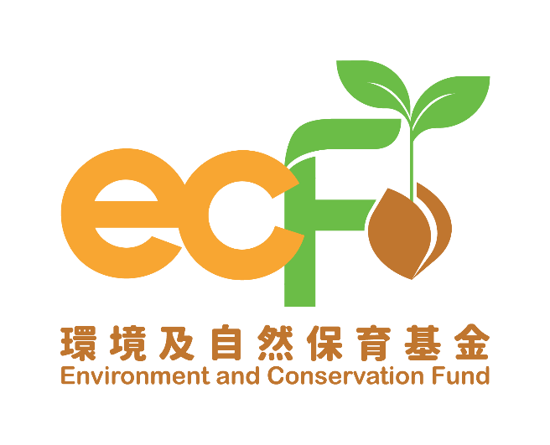
Completion Report
(Applicable to “Clean Shorelines (Small Scale) Projects” Only)

Funding Scheme: |  | Practice and Action Projects – Clean Shorelines (Small Scale)
Project Number: |  | P&AXXXX
Project Title: |  | Environment and Conservation Fund XXXX
Recipient Organisation:
Project Period:
Report Submission Date:
Declaration of Person-in-charge/Project Leader:  Note:  This report shall be signed by the person-in-charge or the project leader as stated in the application form, unless otherwise agreed by the Secretariat. |  | I certify that the attached completion report and statement of accounts are correct, including:  - the collaborating organisations and/or service providers/contractors and/or the project employees under the captioned project have signed the Confirmation on National Security;  - the goods and services purchased, acquired and charged to this project are for the sole use of the project and that the prices are fair and reasonable;  - the expenditure charged to the project has been settled and that it has not been/will not be claimed under other project(s) funded by the Environment and Conservation Fund or subsidised by other source(s) of funding; and  - *the balance of grant to be claimed/the amount of unspent grant to be returned to the Environment and Conservation Fund is correct.  *Delete whichever is inappropriate.
Information of the Person-in-charge/Project Leader
Name:

Position Held:
Signature: |  |  | Official Chop of Organisation:

Please complete this completion report and submit it to the Secretariat within one month upon the completion of the project. Please note that this completion report will be reviewed by the Vetting Subcommittee and, where necessary, be made available for public inspection. In addition, basic information of the project and the information contained in Part (I) Summary of Completion Report of this report may be uploaded to websites of the Environment and Conservation Fund for public inspection and sharing of project outcomes.

- Summary of Completion Report

Project Period | From |  | (dd/mm/yyyy) to |  | (dd/mm/yyyy)
Target Participants | e.g. 40 public audience
Project Activities | e.g. Shoreline cleanup at Tai Long Wan, Shek Pik, Lantau Island x 2 times
Project Outcomes | - Assessment of effectiveness  Activity Date (dd/mm/yyyy) Total Weight of Refuse Collected (kg) No. of Participants (Headcount)  Anticipated Actual Achievement Status (Please select “✓” if achieved) Anticipated Actual Achievement Status (Please select “✓” if achieved)  e.g. 01/06/2025 50 60 20 19  e.g. 15/06/2025 50 55 20 21
 | - Major categories of marine refuse observed (Please tick “✓” as appropriate)
Activity Date  (dd/mm/yyyy) | Plastic | Foam Plastic | Paper/  Cardboard | Wood | Rubber | Glass/Ceramic | Metal | Others  (Please specify)
e.g. 01/06/2025 | ✓ |  |  |  | ✓
e.g. 15/06/2025 | ✓ |  | ✓

- Details of Completion Report
- Clean Shorelines Activity Photos (Please submit a set of photos for each activity to show the difference in shoreline before and after cleanup, participants cleaning up the shoreline and the refuse collected. Please expand this section if there were more than 2 cleanup activities.)

Activity Date: |  | (dd/mm/yyyy) | Activity Time: | From | To
Shoreline appearance (before cleanup) |  |  | Shoreline appearance (after cleanup)
Participants cleaning up the shoreline |  |  | Refuse collected

Activity Date: |  | (dd/mm/yyyy) | Activity Time: | From | To
Shoreline appearance (before cleanup) |  |  | Shoreline appearance (after cleanup)
Participants cleaning up the shoreline |  |  | Refuse collected

- Publicity or educational materials produced (please attach a copy for each type of materials):

Type* | Number of Copies Produced | Number of Copies Distributed
*Examples include newsletters, posters, leaflets, mock charge statement, press clippings, etc.

- Overall evaluation of the project (If certain targets could not be achieved, please provide the main reason(s))*:

*If there are any funded activities not completed or being cancelled, the recipient organisation must submit a written explanation to the Secretariat.

- Financial reporting

4.1 Overall position

Opening balance on project commencement date: | HK$
Income during the project period*: | HK$
Less expenditure during the project period*: | HK$
Closing balance on project completion date: | HK$

*Please provide the breakdowns of income and actual expenditure by completing the statement of accounts provided by the Secretariat.

4.2 Mailing address of payment cheque:

