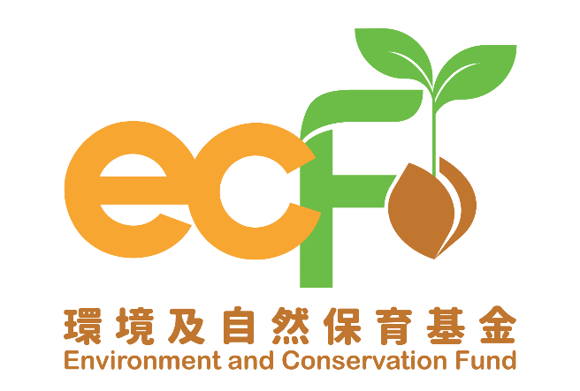
Completion Report
(Applicable to All Project Themes
Except “Clean Shorelines (Small Scale) Projects” and “Surplus Food Recovery Projects”)

Funding Scheme: |  | Practice and Action Projects – XXXX Projects
Project Number: |  | P&AXXXX
Project Title: |  | Environment and Conservation Fund XXXX
Recipient Organisation:
Project Period:
Report Submission Date:
Declaration of Person-in-charge/Project Leader:  Note:  This report shall be signed by the person-in-charge or the project leader as stated in the application form, unless otherwise agreed by the Secretariat. |  | I certify that the attached completion report and statement of accounts are correct, including:  - the collaborating organisations and/or service providers/contractors and/or the project employees under the captioned project have signed the Confirmation on National Security;  - the goods and services purchased, acquired and charged to this project are for the sole use of the project and that the prices are fair and reasonable;  - the expenditure charged to the project has been settled and that it has not been/will not be claimed under other project(s) funded by the Environment and Conservation Fund or subsidised by other source(s) of funding; and  - *the balance of grant to be claimed/the amount of unspent grant to be returned to the Environment and Conservation Fund is correct.  *Delete whichever is inappropriate.
Information of the Person-in-charge/Project Leader
Name:

Position Held:
Signature: |  |  | Official Chop of Organisation:

Please complete this completion report and submit it to the Secretariat within two months upon completion of the project. Please note that this report will be reviewed by the Vetting Subcommittee and, where necessary, made available for public inspection. In addition, the basic information of the project and the information contained in Part (I) Summary of Completion Report of this report may be uploaded to the Environment and Conservation Fund website for public inspection and sharing of the project outcomes.

- Summary of Completion Report (please expand the form if necessary)

Project Period | From |  | (dd/mm/yyyy) to |  | (dd/mm/yyyy)
Project Objectives
Target Participants
Project Activities | e.g. Recruited buildings/residents in the district to participate in activities for recovery of plastic waste/glass bottles/food waste
Project Outcomes | (A) Number of participants in waste reduction/recovery activities and quantities of recyclables collected
Project Outcomes | e.g. 50 buildings/beneficiaries participated in recyclables collection activities that reduced/recovered (a certain) tonnes of waste/recyclables
Project Outcomes | (B) Number of educational and promotional activities held and number of participants
Project Outcomes | e.g. 5 environmental lectures held, with participation of 200 people
(II) Details of Completion Report

- Quantitative summary of implementation progress on practice and action (please specify each type of waste/recyclables/other indicators and expand the table if necessary):

Date | Targets in Work Plan |  |  |  |  |  |  | Progress during Project Period* |  |  |  | Achieve-ment Status (Please select “✓” if achieved)
Date | Quantity (units)/Weight (kg/tonnes) |  |  |  |  |  |  | Quantity (units)/Weight (kg/tonnes) |  |  |  | Achieve-ment Status (Please select “✓” if achieved)
Date | Collected |  | Re-used |  | Treated or delivered to downstream recycler |  | Residue waste disposed of | Collected | Re-used | Treated or delivered to downstream recycler | Residue waste disposed of | Achieve-ment Status (Please select “✓” if achieved)
Date | A |  | B |  | C |  | A-B-C | A | B | C | A-B-C | Achieve-ment Status (Please select “✓” if achieved)
Types of waste and/or recyclables and/or indicators (Please specify): Food Waste
Jan 2025 | 0 | 0 |  | 0 |  | 0 |  | 0 | 0 | 0 | 0
Feb 2025 | 10 tonnes | NA |  | 9 tonnes |  | 1 tonne |  | 12 tonnes | NA | 10 tonnes | 2 tonnes
Mar 2025
Apr 2025
May 2025
Jun 2025
Jul 2025
Aug 2025
Sep 2025
Oct 2025
Nov 2025
Dec 2025
Total
Types of waste and/or recyclables and/or indicators (Please specify): Plastic
Jan 2025 | 0 | 0 |  | 0 |  | 0 |  | 0 | 0 | 0 | 0
Feb 2025 | 10 tonnes | 1 tonne |  | 8.5 tonnes |  | 0.5 tonnes |  | 12 tonnes | 2 tonnes | 9 tonnes | 1 tonne
Mar 2025
Apr 2025
May 2025
Jun 2025
Jul 2025
Aug 2025
Sep 2025
Oct 2025
Nov 2025
Dec 2025
Total
* The recipient organisation shall provide information about the outlet of recyclables and relevant record photos (e.g. photos of recyclables distribution activities) as proof.

  - Other quantitative summary of implementation progress

2. Education and Publicity

  - Activities held during the project period (please provide two photos for each activity):

Targets in Work Plan |  |  | Progress during Reporting Period
Activity | Content | Planned Number of Participants/ Expected Benefits | Date | Period | Venue | Actual Number of Participants/ Benefits | Achievement Status (Please select “✓” if achieved)
Seminar | Proper recycling guide | 150 | dd/05/2025 | 1.5 hour | XX Community Centre | 180
Seminar | Waste reduction at source | 150 | dd/10/2025 | 1 hour | XX Education Centre | 160
Social media promotion | Create social media page and account | 1000 followers | dd/05/2025 | NA | Facebook page and Instagram account | 1200 followers
Social media promotion | Seminar promotion | 100 likes, 250 clicks | dd/05/2025 | NA | Facebook page | 150 likes, 300 clicks
Social media promotion | Waste reduction tips | 300 likes | dd/06/2025 | NA | Instagram account | 350 likes
Social media promotion | Seminar promotion | 100 likes, 250 clicks | dd/09/2025 | NA | Facebook page | 150 likes, 300 clicks

2.2 Publicity or educational materials produced (please attach a copy for each type of materials):

Type* | Number of Copies Produced | Number of Copies Distributed
*Examples include newsletters, posters, leaflets, mock charge statement, press clippings, etc.

- Project variations and challenges encountered

  - Changes of project schedule, content and/or scope as compared with the approved work plan (if any, please specify the changes with reasons):

* Prior approval shall be obtained from the Practice and Action Projects Vetting Subcommittee Secretariat for any changes of the work plan.

  - Key challenges encountered during the project period, remedial measures taken and their effectiveness (if any):

  - Overall evaluation of the project (e.g. comparison of original objectives and final outcomes, effectiveness and impacts of the project)*:

*If there are any funded activities not completed or being cancelled, the recipient organisation must submit a written explanation to the Secretariat.

  - Other remarks (e.g. improvements that can be made for similar projects in future):

- Financial reporting

4.1 Overall position

Opening balance on project commencement date: | HK$
Income during the project period*: | HK$
Less expenditure during the project period*: | HK$
Closing balance on project completion date: | HK$

*Please provide the breakdowns of income and actual expenditure by completing the statement of accounts provided by the Secretariat.

4.2 Mailing address of payment cheque:

(i) For projects which have adopted the smart reporting applications, please attach the summary report(s) provided by the Secretariat. (ii) Recipient organisation shall report project progress according to the targets set in work plan. (iii) Contents highlighted in grey are provided for reference only, please fill in the table according to the actual situation. (iv) Please expand the table if necessary.

