EE&CA Projects (Demonstration Projects) - “Greening and Biodiversity " Workshop

活動日期Activity dates: | 25 March 2015  或or | 9 April 2015
活動時間Activity duration: | 2:00pm – 5:30pm | 9:00am – 12:30pm
集合時間及地點  Gathering time & location: | 1:45pm | 8:45am
龍虎山環境教育中心(見地圖)
Lung Fu Shan Environmental Education Centre (see map)
名額Quota: | 50 per activity

工作坊內容Workshop Rundown:

第一部分Part 1: 實地認識生物多樣性 Understanding Biodiversity through Field Study
龍虎山郊野公園導賞Guided tour in Lung Fu Shan Country Park (2hrs)
重點Checkpoints | 主題Topics covered
樟樹  Camphor Tree | 原生樹種的用處與樹木的「絞殺」自然現象  Usefulness of native tree species to people and the natural phenomenon of “strangling” of trees
渠道化溪流Channelized Stream | 舊式渠道化對生物多樣性的影響及溪流的自然環境對生物多樣性的重要性  The impact of old channelization methods on biodiversity and the importance of a natural stream environment to biodiversity
外來樹種植林Exotic plantation | 原生樹種對本地生物多樣性的重要性及外來樹種植林的缺點  The importance of native tree species to local biodiversity and the disadvantages of exotic tree plantations
遇見的動植物Encountered flora or fauna | 介紹牠們的適應特點並展示於一個高度城市化的城市裡與我們共存的眾多動植物物種  Introduction to their adaptations and a demonstration of the vast amount of flora and fauna that coexists with us in a highly urbanized city

第二部分Part 2: 生物多樣性示範項目分享Sharing on Biodiversity Demonstration ideas
龍虎山環境教育中心導賞LFSEEC guided centre visit (1hr)
重點Checkpoints | 主題Topics covered
蝴蝶園  Butterfly Garden | 「寄主植物」及蜜源植物的概念（植物對蝴蝶的重要性）  The concept of “host plants” and nectar sourcing plants for butterflies (importance of plants to butterflies)
生機池  Eco-pond | 香港的淡水野生動物及其棲息地  Hong Kong’s freshwater wildlife and habitat

紅外線攝影機及蝙蝠箱  Infra-red cameras & Bat-boxes | 香港的夜行野生動物：蝙蝠和東亞豪豬  Hong Kong’s nocturnal wildlife: bats and Chinese Porcupines
香草螺旋塔  Herb spiral | 生態友善種植香草  An ecologically way to grow herbs
室內展覽  Indoor exhibitions | 龍虎山的生物多樣性及其動植物的適應特點  Lung Fu Shan’s biodiversity and their adaptations

Going to LFSEEC 前往龍虎山環境教育中心:
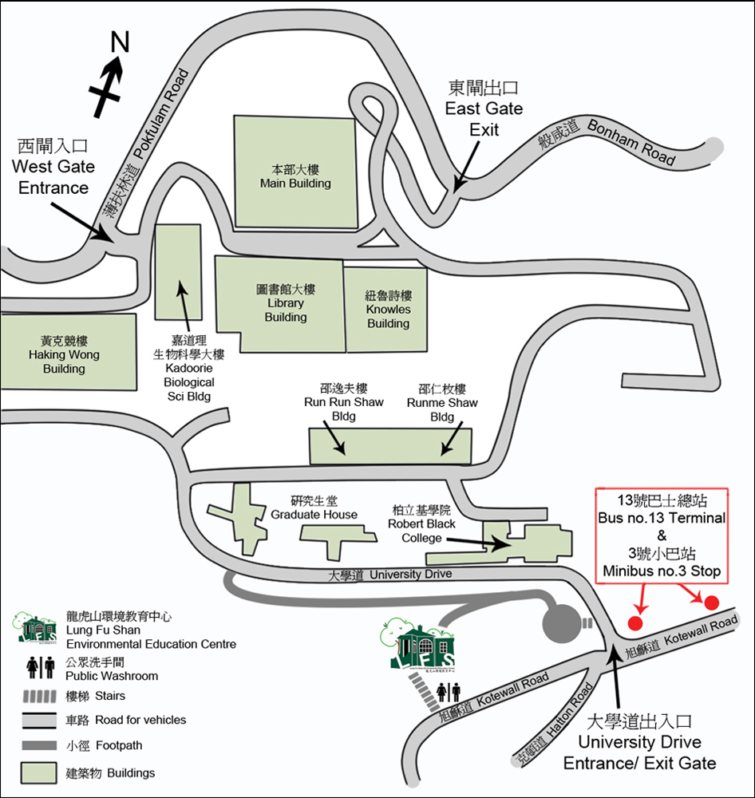
香港大學港鐵站
HKU MTR Station

- 13號巴士 / 3號專線小巴 – 中環(大會堂)至旭龢道 (半山)。
Bus 13 / Mini Bus Route 3 – Central (City Hall) to Kotewall Road (Mid-Levels)
- 從中環乘坐巴士 / 小巴於旭龢道巴士總站下車，步行5分鐘即達。
Take the bus / mini bus from Central to Kotewall Road Bus Terminal. From there it is a 5-minute walk to the LFSEEC
- 從香港大學港鐵站A2出口/ 西閘入口– 經黃克競樓、厲樹雄科學館、研究生堂和大學道，步行約15分鐘到達。
From MTR HKU Station Exit A2 / West Gate Entrance, then pass through Haking Wong Building, James Hsioung Lee Science Building, Graduate House and then University Drive. From there it is a 15-minute walk to the LFSEEC
環境及自然保育基金
環保教育和社區參與項目（示範項目）
「綠化和生物多樣性」工作坊

回條

（請於2015年3月16日（星期一）或之前以傳真或電郵方式交回）

致：環保教育和社區參與項目審批小組秘書處
（經辦人: 朱先生 / 麥小姐）
（傳真： 2827 8138 / 電郵：eeca@epd.gov.hk）

*本校 / 本機構將派員出席是次工作坊。 代表名單如下﹕
 | 代表姓名 | 職位 | 電郵地址 | 聯絡電話號碼 | 手提電話號碼
1.
2.
#由於座位數目有限，每校 / 每機構請提名不多於兩名代表。

*本校 / 本機構擬參加以下場次之工作坊﹕
場次 | 日期 | 時間 | 優先次序 (1, 2, 3)
A | 2015年3月25日 | 下午二時至五時三十分
B | 2015年4月9日 | 上午九時至下午十二時三十分
C | 額外場次(待定)
#秘書處會以先到先得的方式，按報名學校/機構所選取的優先次序安排參加場次。請以 1,2,3 表示優先次序，1 為首選。如申請機構所選取之工作坊場次已滿額，秘書處將考慮安排額外場次之工作坊，詳情另行通知。

*學校／機構名稱 （中文）：
*學校／機構名稱 （英文）：
*學校／機構地址：
聯絡人姓名及職位：
聯絡電話：
傳真號碼：
電郵地址：
日期：

*請刪去不適用者
Environment and Conservation Fund
Environmental Education and Community Action Projects (Demonstration Projects)
Workshop on “Greening and Biodiversity”

Reply Slip

(Please complete and return the reply slip by email or fax
on or before 16 March 2015 (Monday))

To： EE&CA Projects Vetting Sub-committee Secretariat
(Attn.: Mr. Chu / Ms. Mak)
(Fax: 2827 8138 or email: eeca@epd.gov.hk)

The following representative(s) of our *school/organisation will attend the above workshop:
 | Name of Representative | Title | Email address | Contact Number | Mobile Number
1.
2.
#Due to limited availability of seats, each school/organisation should nominate no more than two representatives.

We would like to attend the following session of workshop:
Workshop | Date | Time | Priority (1, 2, 3)
A | 25 March 2015 | 2:00 p.m. – 5:30 p.m.
B | 9 April 2015 | 9:00 a.m. – 12:30 p.m.
C | To be confirmed on a later date on a need basis
# Seats will be allocated on a first-come-first-served basis. Please indicate your preference with 1,2,3 (1 = first choice). In the event that you are not successfully enrolled on this occasion, we will accord priority to your application in case of future workshop(s) which may be arranged on a need basis.

Name of *School/Organisation (English)：_______________________________
Name of *School/Organisation (Chinese)：_______________________________
Address of *School/Organisation：___________________________________
Name and Title of Contact Person：___________________________________
Tel. No.：___________________________________
Fax No.：___________________________________
E-mail：___________________________________
Date：___________________________________
*Please delete as appropriate.

