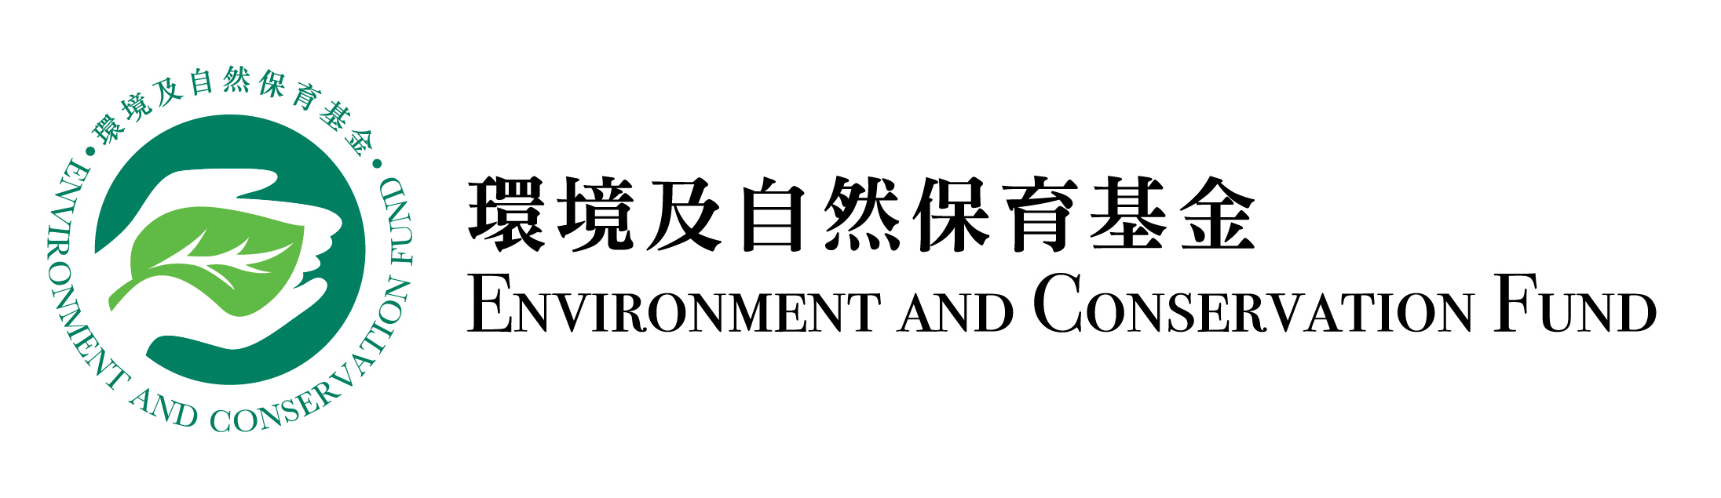
Progress Report
Funding Scheme: |  | Community Waste Reduction Projects – Surplus Food Recovery Projects
Project Number: |  | WRP
Project Title:
Recipient Organisation:
Reporting Period:
Report Submission Date:
Declaration of Project Leader:  Note:  This report shall be signed by the project leader as stated in the application form, unless otherwise agreed by the Secretariat. |  | I certify that the attached progress report and statement of accounts are correct, including:  - the goods and services purchased, acquired and charged to this project are for the sole use of the project and that the prices are fair and reasonable;  - the expenditure charged to the project has been settled and that it has not been/will not be claimed under other project(s) funded by the Environment and Conservation Fund or subsidised by other source(s) of funding; and  - *the balance of grant to be claimed/the amount of unspent grant to be returned to the Environment and Conservation Fund is correct.  *Delete whichever is inappropriate.
Information of Project Leader
Name:
Position Held:
Signature: |  |  | Official Chop of Organisation:

Please complete this Progress Report and submit it by post to the Secretariat every six months (beginning from the project commencement date) or within the timeframe as specified in the Approval Letter (whichever is the earlier). This progress report may be made available for public inspection. Please note that progress reports are for reporting the progress of the project only. A written application must be submitted to the Secretariat for approval of any changes to the project in accordance with the Approval Letter.
- Changes of project schedule, content and/or scope as compared with the approved work plan (if any, please specify the changes with reasons):

- Quantitative summary of implementation progress on waste reduction/recovery

Date | Targets in Work Plan |  |  |  |  | Progress during Reporting Period |  |  |  |  | Achieve-ment Status (Please select “✓” if achieved)
 | Recovery Amount (tonnes) |  | Distribution Amount (tonnes) |  | Number of Benefici-aries (man-time) | Recovery Amount (tonnes) |  | Distribution Amount (tonnes) |  | Number of Benefici-aries (man-time)
 | Fresh Food | Packed or Canned Food | Direct Food Redistri-buted | Cooked Food |  | Fresh Food | Packed or Canned Food | Direct Food Redistri-buted | Cooked Food
Jan 2023 | 0 | 0 | 0 | 0 | 0 | 0 | 0 | 0 | 0 | 0
Feb 2023 | 5 | 3 | 3 | 3 | 20 | 8 | 5 | 5 | 4 | 40
Mar 2023 | 8 | 5 | 6 | 5 | 35
Apr 2023
May 2023
Jun 2023
Total

  - Other quantitative summary of implementation progress

- Education and Publicity

3.1 Activities held during the reporting period (please provide two photos for each activity):

Targets in Work Plan |  |  |  |  |  | Progress during Reporting Period
Activity | Content | Date | Period | Venue | Planned Number of Participants/ Expected Benefits | Actual Number of Participants/ Benefits | Achievement Status (Please select “✓” if achieved)
Seminar | Proper recycling guide | May 2023 | 1.5 hour | XX Community Hall | 150 | 180
 | Waste reduction at source | Oct 2023 | 1 hour | XX Education Centre | 150 | 160
Social media promotion | Create social media page and account | Jan 2023 | N.A. | Facebook page and Instagram | 1 000 followers | 1 200 followers
 | Waste reduction tips | Jun 2023 | N.A. | Instagram | 300 “likes” | 350 “likes”
 | Seminar promotion | May and Sep 2023 | N.A. | Facebook page | 200 “likes” and a hit rate of 500 | 300 “likes”, 600 clicks

3.2 Publicity or educational materials produced (please attach a copy for each type of materials):

Type* | Number of Copies Produced | Number of Copies Distributed
*Examples include newsletters, posters, leaflets, mock charge statement, press clippings, etc.

- Project variation and challenges encountered

  - In case of unsatisfactory progress as compared with the work plan, please specify the reasons and the remedial measures taken, planned and/or recommended (if any):

  - Key challenges encountered during the reporting period, remedial measures taken and their effectiveness (if any):

- Financial reporting

5.1 Overall position

Opening balance at the start of the reporting period: | HK$
Income during the reporting period*: | HK$
Less expenditure during the reporting period*: | HK$
Closing balance at the end of the reporting period: | HK$

*Please provide the breakdowns of income and actual expenditure by completing the statement of accounts provided by the Secretariat.

5.2 Is a further disbursement of fund needed? (please tick as appropriate)

 | Yes* |  | No
 |  |  | (Please forecast the date on which a further disbursement is required (dd/mm/yyyy): | )

*The financial position of the project submitted should justify that not less than 80% of the previous payment(s) has/have been/will soon be spent such that a further disbursement is required for undertaking the project as scheduled.

5.3 Mailing address of payment cheque:

(i) For projects which have adopted the smart reporting applications, please attach the summary report(s) provided by the Secretariat. (ii) Recipient organisation shall report project progress according to the targets set in work plan. (iii) Prior approval shall be obtained from the Waste Reduction Projects Vetting Sub-committee Secretariat for any changes of the work plan. (iv) Contents highlighted in grey are provided for reference only, please fill in the table according to the actual situation.

