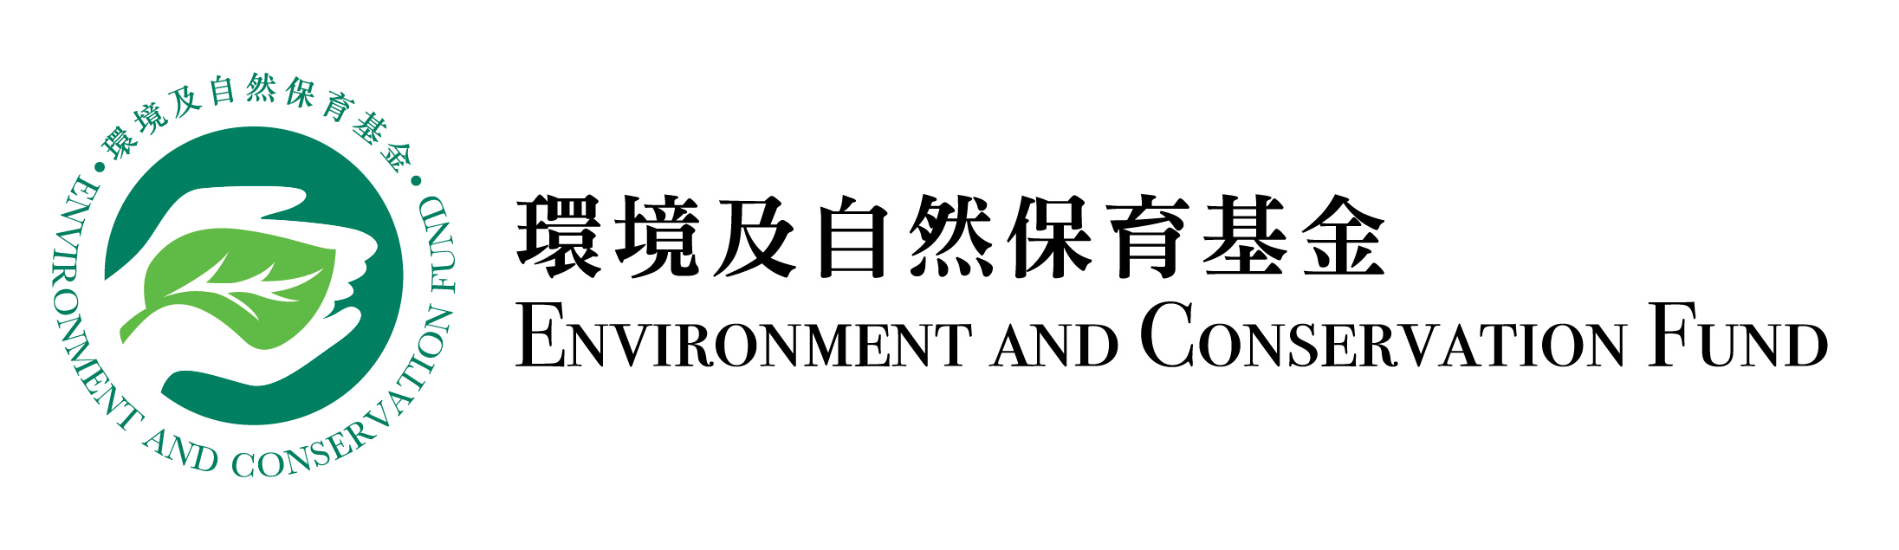
Completion Report
Funding Scheme: |  | Community Waste Reduction Projects – Surplus Food Recovery Projects
Project Number: |  | WRP
Project Title:
Recipient Organisation:
Project Period:
Report Submission Date:
Declaration of Project Leader:  Note:  This report shall be signed by the project leader as stated in the application form, unless otherwise agreed by the Secretariat. |  | I certify that the attached completion report and statement of accounts are correct, including:  - the goods and services purchased, acquired and charged to this project are for the sole use of the project and that the prices are fair and reasonable;  - the expenditure charged to the project has been settled and that it has not been/will not be claimed under other project(s) funded by the Environment and Conservation Fund or subsidised by other source(s) of funding; and  - *the balance of grant to be claimed/the amount of unspent grant to be returned to the Environment and Conservation Fund is correct.  *Delete whichever is inappropriate.
Information of Project Leader
Name:
Position Held:
Signature: |  |  | Official Chop of Organisation:

Please complete this Completion Report and submit it to the Secretariat within two months upon completion of the project. Please note that this report will be reviewed by the Vetting Sub-committee and, where necessary, made available for public inspection. In addition, the basic information of the project and the information contained in Part (I) Summary of Completion Report of this report may be uploaded to the Environment and Conservation Fund website for public inspection and sharing of the project outcomes.
- Summary of Completion Report (please expand the form if necessary)

Project Period | From |  | (dd/mm/yyyy) to |  | (dd/mm/yyyy)
Project Objectives
Target Participants
Project Activities | e.g. Recruited buildings/residents in the district to participate in activities for recovery of surplus food
Project Outcomes | (A) Number of participants in waste reduction/recovery activities and quantities of recyclables collected
 | e.g. 50 food donors participated in surplus food collection activities that recovered (a certain) tonnes of surplus food
 | (B) Number of educational and promotional activities held and number of participants
 | e.g. 5 environmental lectures held, with participation of 200 people
(II) Details of Completion Report

- Changes of project schedule, content and/or scope as compared with the approved work plan (if any, please specify the changes with reasons):

- Quantitative summary of implementation progress on waste reduction/recovery :

Date | Targets in Work Plan |  |  |  |  | Progress during Project Period |  |  |  |  | Achieve-ment Status (Please select “✓” if achieved)
 | Recovery Amount (tonnes) |  | Distribution Amount (tonnes) |  | Number of Benefici-aries (man-time) | Recovery Amount (tonnes) |  | Distribution Amount (tonnes) |  | Number of Benefici-aries (man-time)
 | Fresh Food | Packed or Canned Food | Direct Food Redistri-buted | Cooked Food |  | Fresh Food | Packed or Canned Food | Direct Food Redistri-buted | Cooked Food
Jan 2023 | 0 | 0 | 0 | 0 | 0 | 0 | 0 | 0 | 0 | 0
Feb 2023 | 5 | 3 | 3 | 3 | 20 | 8 | 5 | 5 | 4 | 40
Mar 2023 | 8 | 5 | 6 | 5 | 35
Apr 2023
May 2023
Jun 2023
Total

  - Other quantitative summary of implementation progress

3. Education and Publicity

3.1 Activities held during the project period (please provide two photos for each activity):

Targets in Work Plan |  |  |  |  |  | Progress during Project Period
Activity | Content | Date | Period | Venue | Planned Number of Participants/ Expected Benefits | Actual Number of Participants/ Benefits | Achievement Status (Please select “✓” if achieved)
Seminar | Proper recycling guide | May 2023 | 1.5 hour | XX Community Hall | 150 | 180
 | Waste reduction at source | Oct 2023 | 1 hour | XX Education Centre | 150 | 160
Social media promotion | Create social media page and account | Jan 2023 | N.A. | Facebook page and Instagram | 1 000 followers | 1 200 followers
 | Waste reduction tips | Jun 2023 | N.A. | Instagram | 300 “likes” | 350 “likes”
 | Seminar promotion | May and Sep 2023 | N.A. | Facebook page | 200 “likes” and a hit rate of 500 | 300 “likes, 600 clicks

3.2 Publicity or educational materials produced (please attach a copy for each type of materials):

Type* | Number of Copies Produced | Number of Copies Distributed
*Examples include newsletters, posters, leaflets, mock charge statement, press clippings, etc.

- Project variation and challenges encountered

4.1 Key challenges encountered during the project period, remedial measures taken and their effectiveness (if any):

4.2 Overall evaluation of the project (e.g. comparison of original objectives and final outcomes, effectiveness and impacts of the project)*:

*If there are any funded activities not completed or being cancelled, the recipient organisation must submit a written explanation to the Secretariat.

  - Other remarks (e.g. improvements that can be made for similar projects in future):

- Financial reporting

5.1 Overall position

Opening balance on project commencement date: | HK$
Income during the project period*: | HK$
Less expenditure during the project period*: | HK$
Closing balance on project completion date: | HK$

*Please provide the breakdowns of income and actual expenditure by completing the statement of accounts provided by the Secretariat.

5.2 Mailing address of payment cheque:

(i) For projects which have adopted the smart reporting applications, please attach the summary report(s) provided by the Secretariat. (ii) Recipient organisation shall report project progress according to the targets set in work plan. (iii) Prior approval shall be obtained from the Waste Reduction Projects Vetting Sub-committee Secretariat for any changes of the work plan. (iv) Contents highlighted in grey are provided for reference only, please fill in the table according to the actual situation.

